SERVE & SHINE

SCHOOL IMPROVEMENT PLAN : 2013-14
(RMSA)

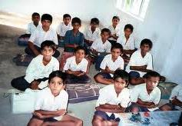
SPECIAL PROGRAMMES IN THE SCHOOL :

- RAMANUJAM BIRTH DAY CELECRATIONS IN SCHOOL LEVEL (MATHS DAY):
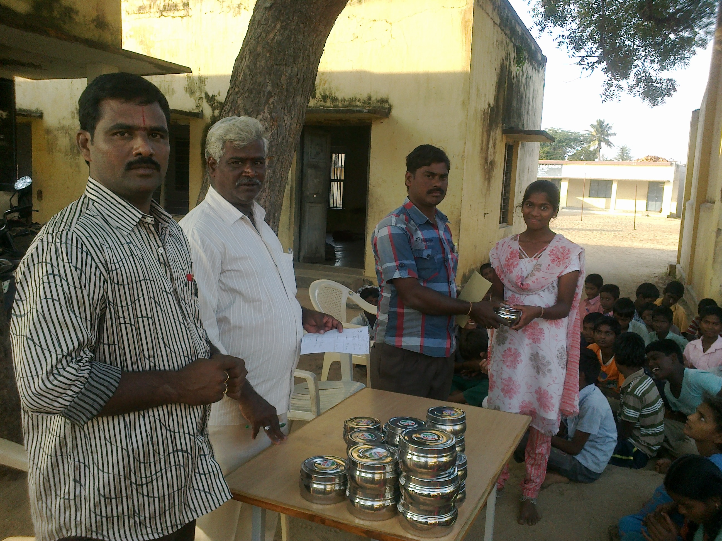
- SCIENCE EXIHIBITION IN THE DIVISION LEVEL :

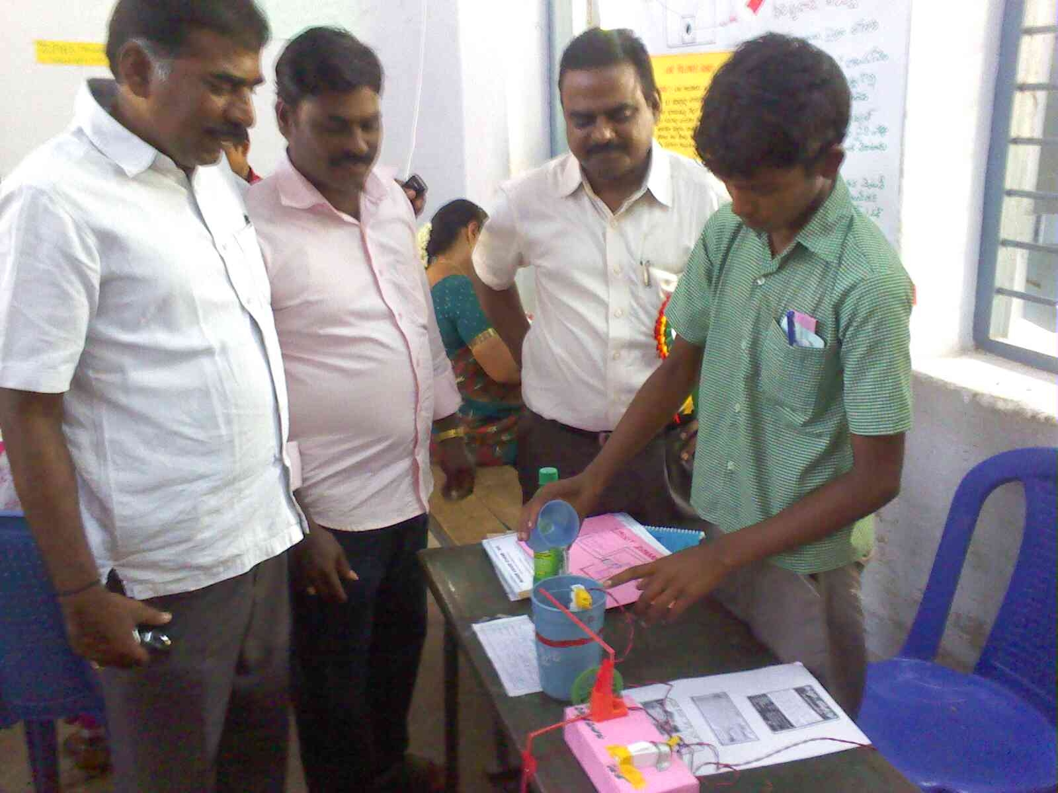

- CULTURAL ACTIVITIES IN THE SCHOOL DAY PROGRAMME :

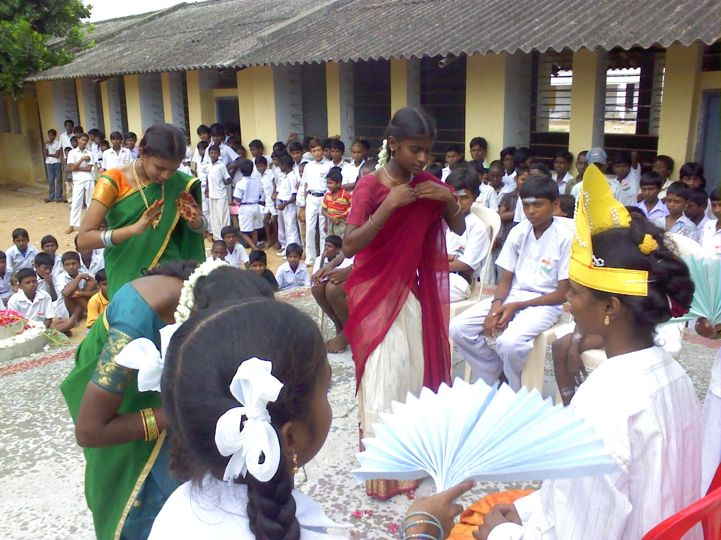

- EDUCATIONAL TOUR AT SCHOOL LEVEL (2012-13) :

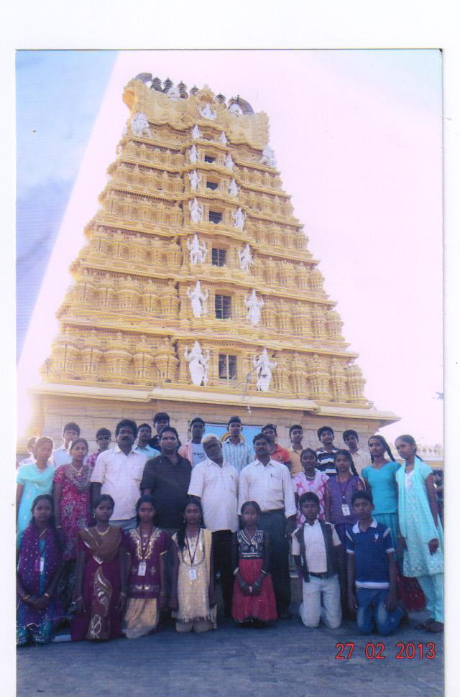
SCHOOL PARTICULARS

Name of the School : Z.P.HIGH SCHOOL
Address : PANNUR
Dise Code of the School : 1021601
Panchayat : PANNUR
Mandal : VIJAYAPURAM
Division : PUTTUR
District : CHITTOOR
Assembly Constituency : NAGARI
Parliamentary Constituency : TIRUPATI
Name of the Headmistress : Sri G.RAVINDRA BABU
Name of the MEO : Sri B. KAILASAM
Name of the Dy.E.O : Sri Dr V.SEKHAR
Name of the D.E.O : Sri T.PRATHAP REDDY
Contact No. of the School (if any) :
(With STD Code)

Contact No. of the Headmaster : 8008641726
E-mail ID of the School : hmzphspannur@gmail.com
Bank A/c No. of the School : 11675427896
STATE BANK OF INDIA, PANNUR
RMSA Bank A/c.No : 31018683022
SMC Bank A/C, No : STATE BANK OF INDIA, PANNUR

INDEX

CHAPTER  NO | TITLE | PAGE NO
1 | VILLAGE PROFILE-GEOGRAPHIC | 5
2 | VILLAGE PROFEILE-DEMOGRAPHIC | 6
3 | SCHOOL PROFILE | 8
4 | NEEDS/GAPS IDENTIFIED FOR IMPROVEMENT | 13
5 | STRATEGIES & INTERVENTIONS | 16
6 | EDUCATION FOR SC/ST/MINORITY/GIRLS | 19
7 | ICT @ 1300 SCHOOLS | 21
8 | INNOVATION | 23
9 | COMMUNITY MOBILISATION | 27
10 | OTHER INTERVENTIONS & SPECIFIC PROPOSAL | 28
11 | HOSTEL FACILITY FOR BOYS & GIRLS | 29
12 | IEDSS (INTEGRATED EDUCATION FOR DISABLED AT SECONDARY STATE | 30
13 | VOCATIONAL EDUCATION | 31

VILLAGE PROFILE –GEOGRAPHIC

The PANNUR is a Major Panchayat with 10 wards. It is a village of VIJAYAPURAM Mandal Which is in CHITTOOR District. Jagannadhapuram, Pannur Substation, Kaliyambakam, Samireddy Kandriga, Mittakandriga, Thellagunta, Ellasamudram, Gollakandriga, Alapakam Kandriga, Buchivanatham, and K.R. Palem are the neighboring villages. In or around in a group of Reddy Community hailed from CHITTOOR and later it was developed as a village with Agriculture as its main potential.
Latitude : 13.3279
Longitude : 79.6812

The village is at the distance of 12 Km from the Mandal Headquarters and 110 Kms from the District Headquarter and 10 kms distance from Tamilnadu Boarder. The Village is connected by Road and the Nearest Railway Station is about in 18 Kms i.e. Nagari (Ekambarakuppam) with a distance of 775 Km from the State Headquarters. The Reddy and SC Community is the dominant community in the Village.

The main activity in the village is Cultivation. The lands are fertile and there is irrigation system for agricultural development. Paddy, Sugarcane, Ground nuts are the major crops. The farmers are educated enough to know the latest trends and developments in their fields. The Village depends on the near by NAGARI MUNCIPALITY Frequent transportation is available by means of Buses and Autos. The ground water is suitable for drinking purposes. Drinking water distribution system is in village maintained by the local Panchayat.

VILLAGE PROFILE – DEMOGRAPHIC

The total population of the village is 2955 with 1483 (50.2%) Male and 1462 (49.8%) Female population. Community wise ST is 6.19%, SC is 44.64%, OBC is 41.48 % and OC is 5.27 % .

Wards | ST |  |  | SC |  |  | OBC |  |  | OC |  |  | Total
Wards | M | F | T | M | F | T | M | F | T | M | F | T | M | F | T
Pannur | 8 | 4 | 12 | 0 | 0 | 0 | 497 | 506 | 1003 | 37 | 42 | 79 | 542 | 612 | 1164
Pannur HW | 7 | 8 | 15 | 547 | 480 | 1027 | 12 | 15 | 27 | 0 | 0 | 0 | 566 | 503 | 1069
Pannur AAW | 0 | 0 | 0 | 143 | 141 | 284 | 0 | 0 | 0 | 0 | 0 | 0 | 143 | 141 | 284
Pannur BC | 4 | 5 | 9 | 5 | 4 | 9 | 20 | 18 | 38 | 0 | 0 | 0 | 29 | 27 | 56
Pannur ST | 68 | 71 | 139 | 0 | 0 | 0 | 0 | 0 | 0 | 0 | 0 | 0 | 68 | 71 | 139
Tellagunta | 3 | 5 | 8 | 0 | 0 | 0 | 85 | 73 | 158 | 47 | 30 | 77 | 135 | 108 | 243
Total | 90 | 93 | 183 | 695 | 625 | 1320 | 614 | 612 | 1226 | 84 | 72 | 156 | 1483 | 1462 | 2955

Source: Census 2011

The 14+ and 15+ age group population is 202 and 201 respectively with 221 boys and 182 girls indicating the gender disparity of 8.23%.

 | Boys | Girls | Total
14+ (Boys & Girls)
15+ (Boys & Girls)

LITERACY

Village Literacy Rate : 53.00%
Mandal Literacy Rate : 60.57%
District Literacy Rate : 67.44%
State Literacy Rate : 61.50%
National Literacy Rate : 65.20%

The village literacy rate is 53.00% which is above the Mandal average of 60.57% and below to the district average of 67.44% and state of 61.50% and also below the National literacy rate. The village Literacy Rate is to be improved at least at par with the National Literacy Rate. Though the village has more no. of teachers, Soft ware Engineers and State Govt. Employees and the Pannur Village is covered with nearly 65% of population with TAMIL CULTURE. The village is behind the District, State and National averages.

Totally the Pannur Village is Covered with following facilities.

- STATE BANK OF INDIA - 01
- MILK DAIRY - 01
- Z.P. HIGH SCHOOL - 01
- M.P.PRIMARY SCHOOLS - 03
- ANGANWADI CENTRES - 03
- POST OFFICE - 01
- GOPALA MITHRA VETERNARY - 01
- PRIMARY SUB HEALTH CENTRE - 01

CHAPTER – III

SCHOOL PROFILE

The School is about 12 Km from the Mandal Headquarter VIJAYAPURAM. It is under the management of Zilla Parishad(Local Body), it was upgraded as a separate Non-Residential High School in the Year of 1960 from the nearby Upper Primary School. The school imparts education for the classes VI to X in both Telugu and English Medium having 12 sections of State Syllabus and is not using the school building as a shift-school.

The School building (Three blocks) is a pucca building with RCC roof housed in a government building. Only 8 class rooms are available for teaching 12 classes. The school has Two units Toilet facility state due to lack of running water. The school having Bore well for drink water facility. Its Boundary wall is partially and needs 100mts to be completed. Last Year 2011-12 Academic RMSA Sanctioned 06 Rooms. 03 Rooms for Classrooms, 01 for Laboratory, 01 for Library and another 01 for Computer room. The school has not sufficient furniture for the students and School having nice Laboratory room. Last 02 years we are purchasing the Laboratory equipements and Library books with RMSA Grants. The school has wide range of nearly 2000 books and having a Library Room. The School has 01 Computer Room with 11 Computers are functioning with 02 faculties.

The school has 18 teaching staff and 03 Non Teaching Staff under permanent establishment. The School has 02 Vacant Posts i.e. Drawing Master and Watchman. Out of 17 teaching staff 03 are OC, 10 are BC, 03 are SC. All the teachers have the Good Academic qualifications and all are professionally trained. Some of them are Graduates and some are Post Graduates. The School has the Physical Director for the benefit of children.

HM | SA | Gr.II LP(Tel)/DM | PD | Non Teaching Staff | Computer Faculty
01 | 14 | 02 | 01 | 03 | 02

The school has maintaining the good enrolment in last 10 years. 397 in the Year 2007-08, 365 in the Year 2008-09, 361 in 2009-10, 354 in 2010-11, 361 in 2011-12 and 355 in the current year 2012-13 marking downtrend which is alarming.
YEAR | Boys | Girls | Total
2007-08 | 222 | 175 | 397
2008-09 | 207 | 158 | 365
2009-10 | 197 | 164 | 361
2010-11 | 176 | 178 | 354
2011-12 | 178 | 187 | 365
2012-13 | 178 | 179 | 357

S.S.C. RESULTS :

Gradually Improvement in SSC Reults in last 07 years. In 2008-09 Year 01 Student Select in PRAJWALIKA Scheme and 01 Candidate Selected (N.PUSHPALATHA) for IIIT Course in IDUPULAPAYA, CUDAPAH District. In 2011-12 year 05 Candidates selected in IIIT Course in IDUPULAPAYA, CUDAPAH District.

S.No. | Year | Appeared | Pass | Pass %
1 | 2005-06 | 91 | 45 | 49 %
2 | 2006-07 | 92 | 72 | 78 %
3 | 2007-08 | 75 | 71 | 95 %
4 | 2008-09 | 84 | 57 | 68 %
5 | 2009-10 | 79 | 76 | 96 %
6 | 2010-11 | 78 | 76 | 97 %
7 | 2011-12 | 81 | 80 | 98.6 %

The School has School Management Development Committee (SMDC) with Headmistress as the Chairman,

Chairman - 1
Faculty Members - 4
Parent Members - 2
Grampachnyayat Members - 2
Ednl. Develop. Committee Member - 1
Mandal Educational Officer - 1
Educationist - 1

School Building Committee & Academic Committee is its subsidiaries.All the students studying in the school have the aim to reach the highest position in every aspect in Academic as well as other activities. Pannur Village covered with Employees and Old Students Welfare Society in which members are teachers who are working in different schools. With the Co-operation of old Students Association, Villagers we are Conducting the GOLDEN JUBILEE FUNCTION on 16.01.2010. An NGO, CFCD ( CHILD FOCUSSED COMMUNITY DEVELOPMENT PROJECT) Chiristian Minority Mission is also extending their Co-operation with helping hand in the development of the School functioning ( Organising Summer Coaching classes for IX Class students, Supply Study Material for X Class students and conducting student awareness compaign in School Premises for Girl Childrens).
This academic year 2012-13 we are conducting the SATHYAVEDU ZONAL SPORTS MEET at ZPHS, Pannur. In this Games and Sports meet our School Childrens are Participate and getting 10 – 15 Prizes. The Games & Sports meet inaguarated by Our Hanourable Deputy Educational Officer, Puttur Sri. V. SEKHAR Garu & Siddartha Educational Institutions Secretary Donar Sri. K.ASHOKA RAJU Garu.
SATHYAVEDU ZONAL MEET INAGUARATION :: 2012-13.

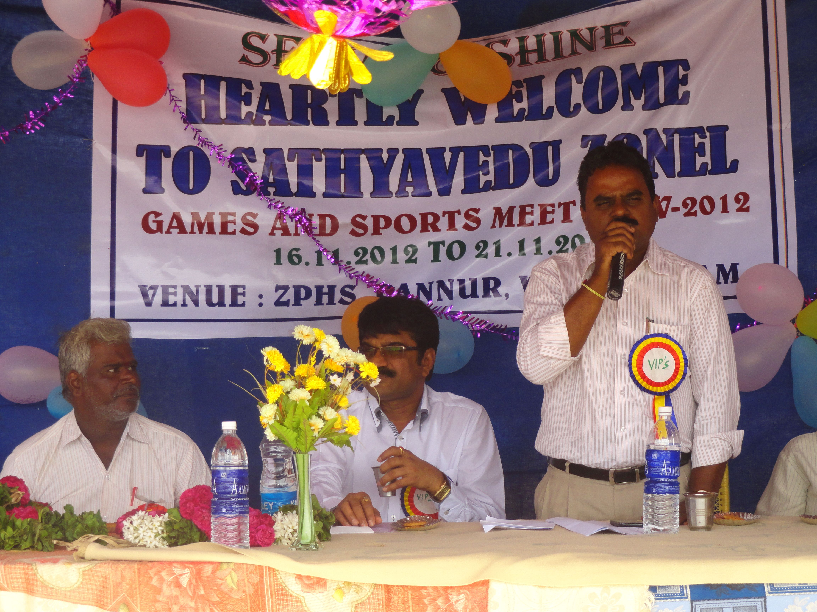
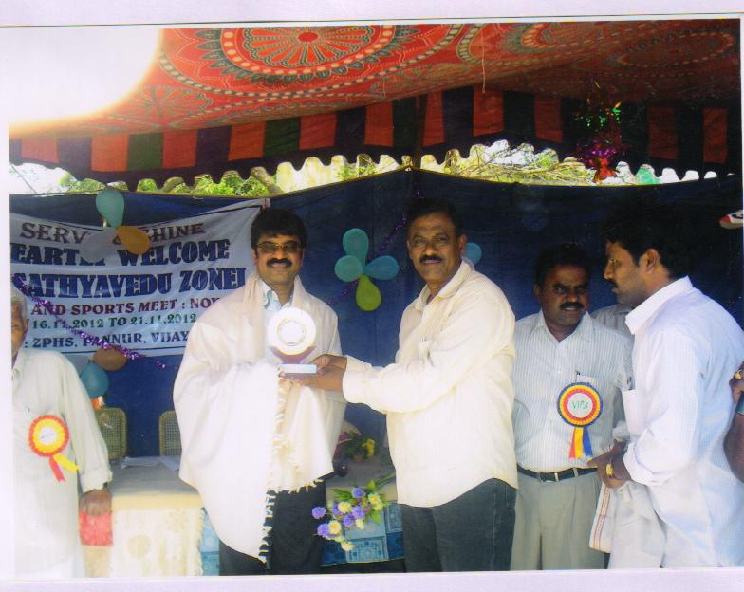
WINNERS TEAM MEDALS & TROPHY WITH PHYSICAL DIRECTOR & THEIR TEACHERS :
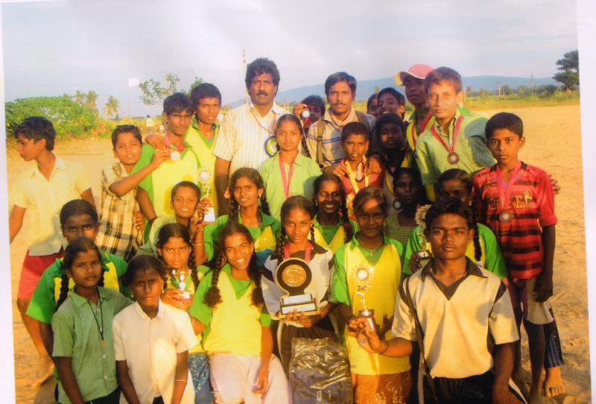

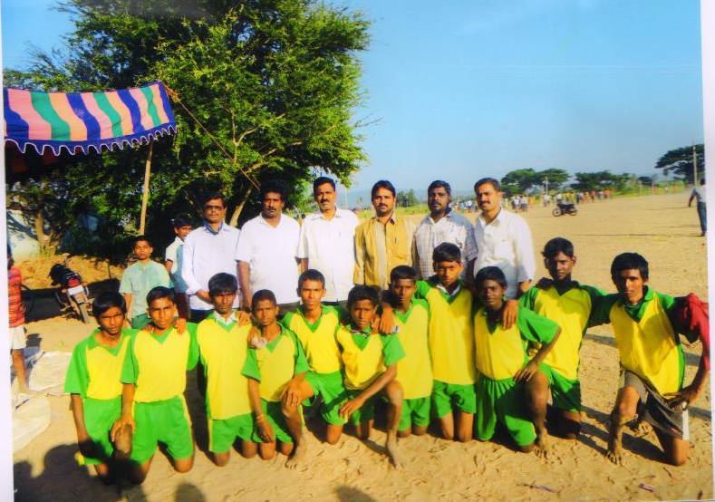

NEEDS/GAPS IDENTIFIED FOR IMPROVEMENT

The school is achieving good results in academics but not up to the mark in the physical infrastructure like Toilet Blocks, Class rooms, Laboratories etc. The villages like Kaliyambakam and Samireddy Kandriga have no conveyance facilities. Access is one of main reason for dropout rate in the admissions. Though the school topper is with 10/10 Points and 98% pass percentage, parents are joining their children in other private schools only for their crazy reasons. If the above said infrastructure is provided they may turn towards our school.

The ZPHS, Pannur is in the jurisdiction of the Puttur Education Division though it is physically in the Chittoor Revenue division . The village comes under NAGARI Assembly Constituency and CHITTOOR Parliamentary Constituency.

As the school has Two Toilet Blocks, it became lack of running water facility. The School having Bore well drinking water facility in the school. Conveyance facilities are to be improved.

Mr. G.Ravindra Babu is the Headmster of the school. All the teachers in the school are professionally trained and they are getting training at regular intervals to update themselves with the recent updates in the subject as well as in methodology and in improving their professional efficiency.

The school needs fund for meeting the Major repair of avoiding leakage from the roof. Even though the building was constructed in 2007-08 the roof is leaking in rainy season and the Doors, Windows are to be repaired. As the School Secured 1st Position in the Mandal in Possessing marks most of the Villagers realized that the school is better than many and the staff are working their best to make it best.

To reduce the dropout rate in VII & VIII Classes, campaigning the importance of education, about the School Activities, Results through Local TV Channels with Govt. & Non-govt organizations to Conduct like BADIBATA PROGRAMME, BALIKA MELAs, KALAJATHAs and ENROLMENT DRIVE Programmes will increase the enrolment.

Increasing the learning resources through community mobilization and by organizing the lectures/seminars by subject and professional experts will bring lot of change in developing the awareness of the present day situation and in promotion of holistic development of children in all walks of life. Subject Clubs, Laboratories will increase the learning resource and enrich the academic concepts.

Every year One week long adolescent education programme is being organized duly utilizing the services of the specially trained teacher in that area so that the children who are in the adolescent age can get guidance to understand the physical, psychological, physiological changes and controlling their emotions. Before the examinations, to motivate and to increase the confidence levels the interaction with eminent psychologists are being invited.

For bridging up the above said gaps approximately an amount of Rs.15 Lakhs is required for construction of Sufficient Classrooms, Toilets, and Drinking water, Minor repairs of the Class rooms, Compound was facilities for providing other basic amenities the problem of conveyance may be solved by issuing loans to the unemployed of the remote villages to purchase Auto’s.

PREPARATION OF TOOLS FOR CONTINUOUS AND COMPREHENSIVE
EVALUATION (C.C.E.)

Base Line Test, Monthly Unit Test, Mid-term Examinations, and Assignments, are conducted with the help of the DCEB and the Teachers. Question-wise analysis is also made to know the learning levels of the students. For VI to VIII Class students from 2012-13 Academic Year the Education Department is implementing the CONTINUOUS AND COMPREHENSIVE EVALUATION. This is helping to us knowing the Various stages, learning

Budget provision may be made to Prepare the Model Papers to Practice CCE for implementing the above said innovations and Rs.10,000/- are required.

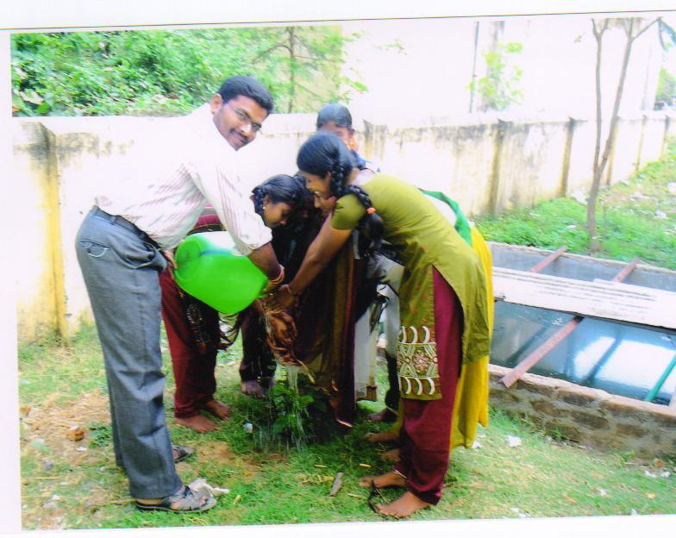

CHAPTER – V

STRATEGIES AND INTERVENTIONS

There is no quantitative expansion for a new school. The existing schools may be strengthened for imparting quality education. The schools need at least three more class rooms immediately. There are no other rooms in the school and they may be prioritized after fulfilling the classrooms.

There is lot of potential for enrolment of class IX if conveyance facility from the feeder villages is improved. Some parents are joining their children for want of English Medium. The so called Corporate schools are offering some incentives (waiving off fee etc.) and grabbing the meritorious students into their schools. If the government facilitates the same they stay here only.
Strategies to bring back class VIII graduates who dropped out are implemented in the catchment area. Campaigning about the school in the Gram Panchayath explaining the positive strengths of the school like abilities and qualifications of the teachers working in the school are giving fruitful results.
I herewith propose the budget for the above said activities as Rs.1,00,000/-
By providing quality infrastructure and learning resources, the school can be developed. Guest Lectures, Seminars, Workshops on the subject content can improve the learning skills among children. As the village is neither interior nor hilly terrain, providing of residential accommodation for female teachers may be utilized for other needy places. The teachers are paying maximum efforts for the holistic development of the children through promotion of sports, cultural activities, exposure to life skills with regard to health, nutrition and personality development.

The school invites agricultural officers, Horticultural officers, Forest Range Officers, artisans and other professionals to create awareness among the students about vocational, professional education and ecological system. There is no trained teacher in Centre for Cultural Research & Training(CCRT) for which application was sent to impart training for at least one teacher and provide cultural kit

The school has subject clubs headed by the concerned subject teachers and they conduct the literary activities, quiz competitions and preparing project works. The school participated in the Science Fairs’ which were organized at different levels. The school has handful of books and one teacher is holding the responsibility of librarian also apart from his/her academic duties. The non language teachers are adjusting their time table so that every week at least one period can have learning while doing in the labs. The School observes week long adolescent education programs, every year so that they can understand the mental, physical, physiological changes occur at this age. The government is providing, special training, material and financial liabilities for this purpose. Two teachers are working as counselors for Guidance in both academic and non academic matters.

The SMDC has met 04 times in this academic year and discussed for the development of the school and children activities. Immediately after the completion of either Unit Tests or Terminals, the PTA meeting will be called for to discuss the achievement, answer scripts will be shown to the parents to know the performance of their children. Progress Report will be issued after every examination. The Pupil-Teacher Ratio is 1:25 which is good and no teacher was deputed in the last academic year on Non-academic works. No teacher was irregular and No one is on Leave on Loss of Pay (LLP).

The average attendance of the school in last year is in between 85% and 95%. If the conveyance facilities are improved it can be improved. The school observes all the days of importance and celebrates all the festivals of the National Interest. Proposed Budget for implementing above strategies the school requires Rs.20,000/-

EDUCATION FOR SC/ST/MINORITY COMMUNITY & GIRLS

As the SC, ST and Minorities are good at enrolment and success rate. Member for SC, ST in the SMDC will hold the responsibility for the above strategies. As this result they are stepping ahead with good scores.

QUALITY EDUCATION WITH T.L.M. :

The grant for the TLM (2000) was utilized for the purpose for which it is meant. The slow learners will be taken care of by imparting remedial coaching and micro teaching. The school also conducts “BADI BATA” program at the starting of the academic year in the month June,2012 to reduce drop-out rate.

The students have the facility to know what the opportunities for their career and future. They have guide teacher to explain all these things. There is No hostel facility for both BOYS & Girls in the village. If government to provide Hostel facility in this village, then we have to improve the maximum strength from nearby villages. The Retention Rate for the previous Academic Year is nearly 97%.
As the local representative people like Late.K. BALA MUNIRATHNAM, Rtd. Teacher, Old Students Association, CFCD Project, local Sarpanch and Local Educationists are interested in education, with the help of them the school announces prizes, awards and incentives, even financial assistance for the poor CWSN students. The school also awards the children with good attendance to improve the average attendance. The absenteeism of the student will be informed through messaging, teacher visits to their houses, keeping in notice to the Parents, Concern teachers and SMDC members.
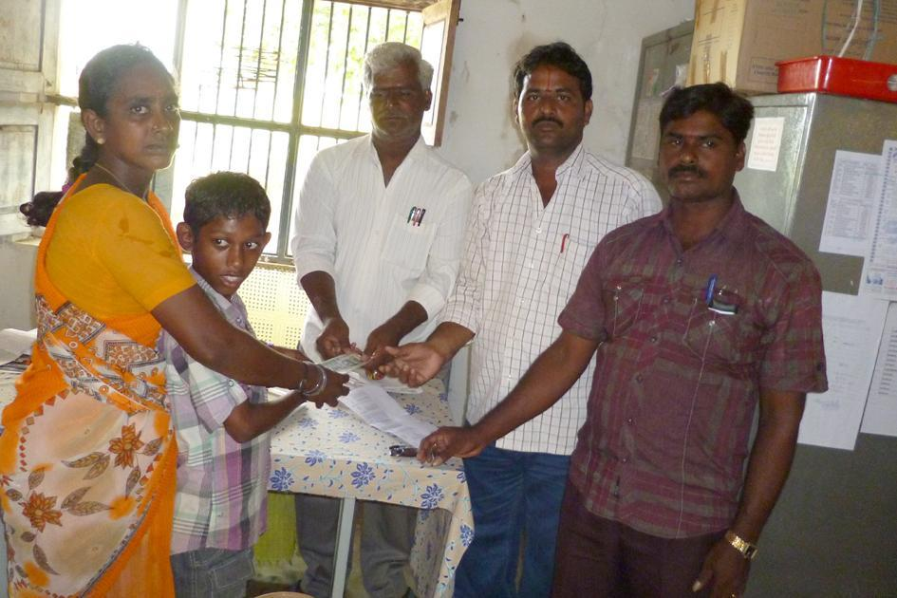

SPECIAL COACHING CLASSES:

Special Coaching classes for the slow learners, especially for SSC students are being conducted. The school conducts classes for them even in term holidays and Sundays also. VIJAYEEBHAVA programmes are being held at mandal level duly orienting them about the new trends & techniques to get above A GRADE. The Teachers are interested to Conducting the Special Classes in Morning,Evening sessions, IInd Saturday and Sunday’s also.

Z.P.High School, Pannur, Vijayapuram Mandal is Covered under the ICT @ 5000 Schools in the year 2008-09 CAL Programme. The Everonn Agency Provided the following facilities
Computers = 10 + 01
C.P.U. = 03
UPS = 05
Generator = 01
Printer = 01
Chairs = 20
Instructors = 02
From VI to X Class Students Learning the Computer Aided Learning Classes Twice in a week. The neighboring schools With in 1km radious Primary School III to V Class Childrens are also attending CAL Programme classes. The students are interested to learn the Painting, word typing, Excell worksheets etc. The School having INTERNET facility also.

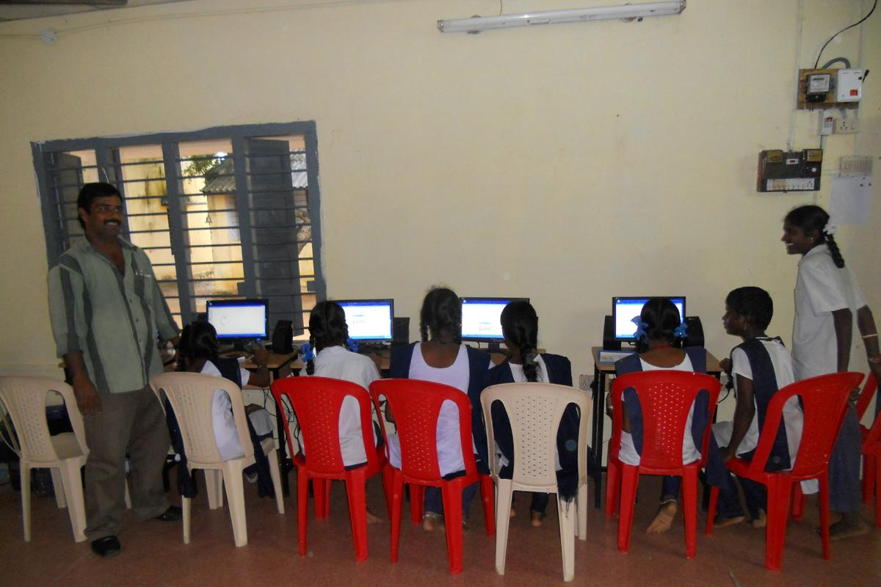
ICT Progress upto dated so for :
The following number of Students were trained in the Computer Education in our School level.
Academic year | No of Students trained
2007-2008 | 397
2008-2009 | 365
2009-2010 | 361
2010-2011 | 354
2011-2012 | 365
2012-2013 | 357

This I C T @ 1300 School project Improved our school Roll . It is Very good programme to Rural Children.

Some Gaps in this Programme :
1. Syllabus Text Books not supplied in the starting of the academic year.
2. Evaluation for the students regarding computer education was not done.
3 .Supply of Kerosene & petrol should be regularized.
4. Appoint Qualified Faculties with Attractive Salary.
5 .Internet connections should be restored.
Proposed Budget per year Rs : 2,50,000/-

INNOVATION
Once in every Year a health check up camp is to be organized in the school by the PHC. Eye Camps for the children are conducted by service organizations.
Guidance Counseling Centers are to be established by professional for the sake of students. At least at Mandal Level one Teacher who is specialized in Guidance & Counseling may be appointed and he may be expected to visit all the high schools in that mandal every month on rotation basis.
As the school ground is adopted by the local Forestry Dept., the students are given work experience training by the experts of the Horticulture Dept., to care the greenery and planting techniques at their homes. The agricultural kits may be supplied to the school.

PROGRAMMES RELATED TO PROTECTION OF ENVIORNMENT:
NATIONAL GREEN CORE students are organizing special activies in the Concern. The School children are emphasized on
“REDUCE – RECYCLE –RECUSE”
The School is taking care to to be role model in saying NO TO PLASTIC. The Garbage in the School is divided in to Bio-degradable and Non-degradable for the usage in making Vermin Compost for the Plants in the School. The action plan in this aspect is under Process.

N.G.C. PROGRAMME IN THE SCHOOL CAMPUS :.

The School is implementing the N.G.C. Programmes. Under this programme the students are divided in to different groups do their Activities under the supervision of Guidance Teachers Sri. D.Govardhanam, SA(BS) , Sri.K.D. Saradhy, SA (PS), Sri B. Sreenivasulu,SA(BS), Sri. P. Jayadev, SA(PD) and Sri. B. Suresh Babu, SA (MM).
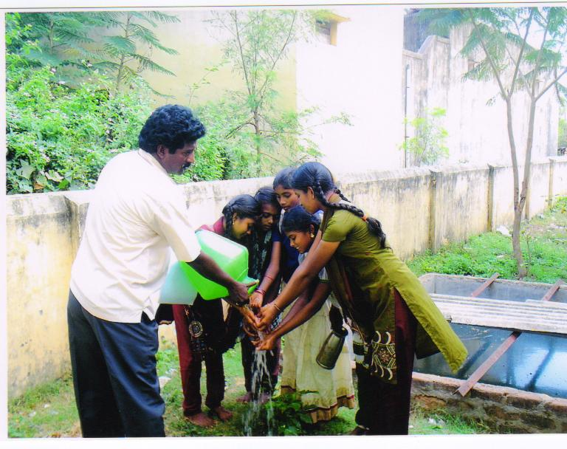
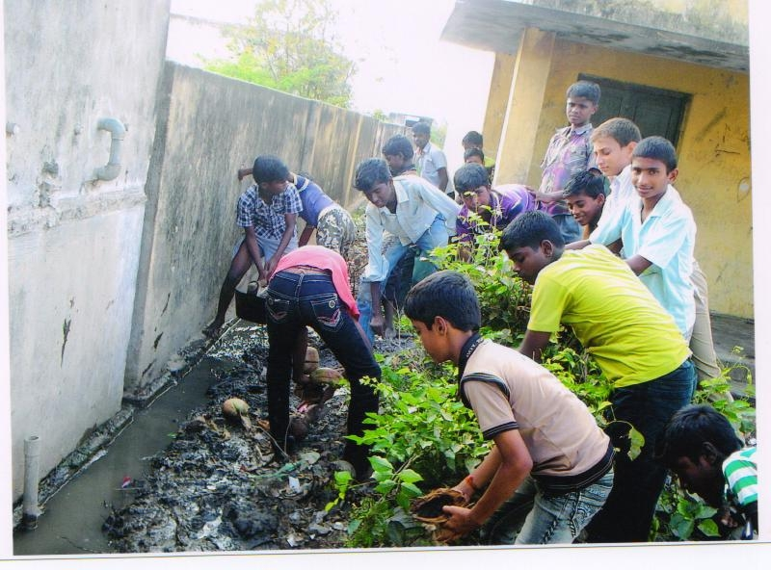
PLANTING IN SCHOOL PREMISESS BY NGC COMMITTEE:
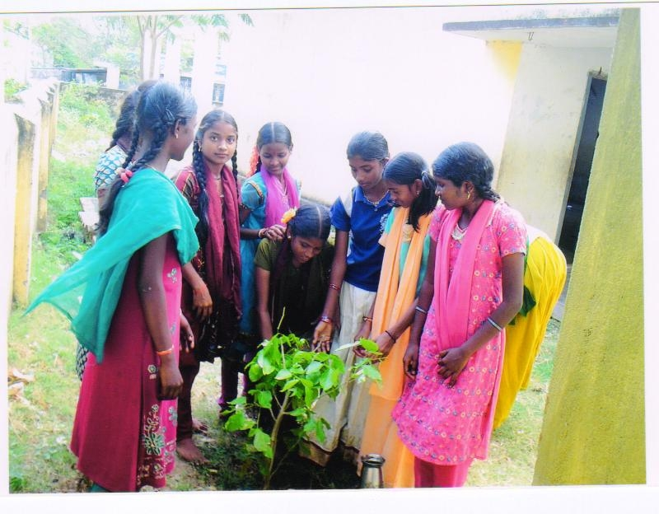

CLEANING THE SCHOOL PREMISES WITH N.G.C. CORE TEAM MEMBERS :
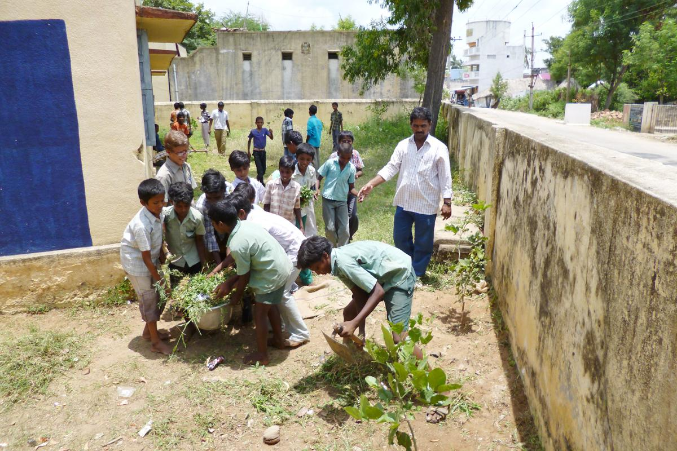

MARCHFAST BY N.G.C. TEAM :
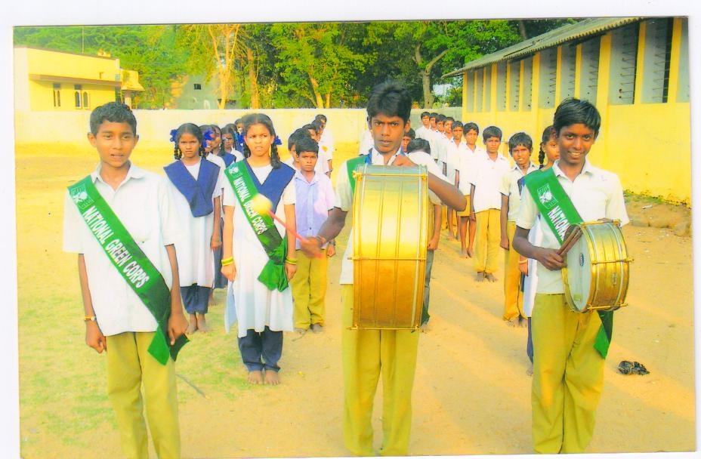

TRAINING OF CHILDREN IN LIFE SKILLS & CAREER GUIDANCE :

- Training the Girls life skills is done by the guest lectures by the
experts in different fields.
2. By training them in vocational skills like tailoring, candels making,spiral binding,chalk making.greetingcards preparation.
3. Requesting the diet lectures to come and train the students in this
concerned.
4. The LEAD INDIA – 2020 PROGRAMME is build the Capacity of the Student and Developing the National Spirit among them.

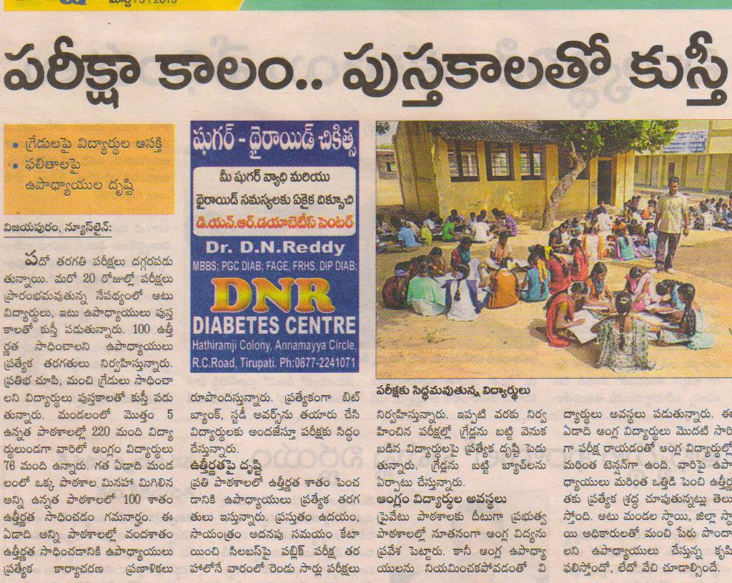

COMMUNITY MOBILISATION

The parents of the students who are attending in other schools will be met and convinced to join their children in our school duly explaining the conditions and abilities of the school and teachers, results achieved, positions held by our students in different examinations and strengths of the school.

The teachers in the government schools are more qualified and experienced than those are working in the private schools. The school has secured high position in the district as well as in imparting the quality education. Special classes for the slow learners will be arranged. There is no necessity for the private tuitions etc. These points are to be inculcated in the minds of the parents.

The students selected for IIIT from the school and old students employed in different sectors residing in the village are together guiding the present batches in career options and future studies.

In this aspect the PTA is also to be trained in the areas of how deal the adolescent children and take care about their future. The training is to be given by the local leaders, youth etc.

The attitude of some sector of people, who feel that sending their children to Government school is inferior to their prestige is to be changed.

The proposed budget is Rs.20,000/-.

SUGGESTED INTERVENTIONS AND SPECIAL PROPOSALS : -

1. To impart intensive in-service training to the teacher to elevate their
teaching capabilities.
2. To make the child to undergo regular health checkup, and give
necessary medical assistance.
3. Along with the Mid-day Meals the child has to be given a glass of Milk.
4. The Vitamins for Calcium, Iron, and Vitamin -A, have to be supplemented for the High School children especially for girls.
5. To provide equipped Laboratory and furnished Library along with
Librarian.
6. To provide proper conveyance for the students coming from the
surrounding villages.
7. Bicycles are to be given for the children coming from the distant native villages.
8. Urinals & Toilets with running water facility are to be provided as they are very important for girls.
9. Hostel facility for the girls coming from the interior places.
10. Complete Games and Sports equipment are to be supplied for the all round development of the child
Proposed budget for the above strategies :- Rs. 25,00,000/-

BOYS & GIRLS HOSTEL
There is No Hostel for Boys and Girls in the Village. But there is a needy to open Boys and Girls Hostel for SC,ST and BC students. In this Connection nearly 60-70
Pannur village Students are going study in the neighboring hostels like NAGARI and PICHATUR . If we have to open the hostels to improve the Strength in nearby Villages. I am giving here with Girls strength in our school in the following academic year.
Academic year | Boys | Girls | Total
2007 – 08 | 222 | 175 | 397
2008 - 09 | 207 | 158 | 365
2009 – 10 | 197 | 164 | 361
2010 - 11 | 176 | 178 | 354
2011 - 12 | 178 | 187 | 365
2012 - 13 | 178 | 169 | 357

By observing the figures this is need to open Girls Hostel.
PROPOSED BUDGET FOR BUILDING& MAINTENANCE. : Rs.15, 00,000/-

.

IEDSS (INTEGRATED EDUCATION FOR DISABLED AT SECONDARY STAGE)

In our School we have nearly 12 CWSN Childrens. They need Special attention by a trained Teacher. In our School Complex level nearly 25 CWSN Childrens. In our Vijayapuram Mandal IED Resource Person Mr. K. Balaji is regularly visiting the CWSN Persons. This Academic Year RAJIV VIDYA MISSION (SSA), CHITTOOR is Provided nearly 15 Opticals to Low Vision Students in our School. So there is need open IEDSS on our school.
Mentally Retarted = 03
Visually Impaired = 10
Hearing Impaired = 05
Ortho Handicapped = 05
TOTAL = 23
Proposed budget Rs. 5, 00,000/-

CHAPTER – XIII
VOCATIONAL EDUCATION
There is no any regular programme for vocational educational. But there is need Vocational Skills for boys and girls to improve their skills in vocational education. Hence there is a need to open vocational courses in our School in the following trades.
- Radio, T.V Repair & Mechanism.
- Tailoring Classes for Girls.
- Chalks and Phenols making
- House wiring.
- Cell phone repair
- Computer Hareware and Software

Proposed budget-Rs. 10,00,000/-.

G. Ravindrababu
HEADMASTER
ZPHS, PANNUR,
VIJAYAPURAM MANDAL

